


PROJECT REPORT
GROUP CHOSEN AREA OF INTEREST: AGRICULTURE
PROJECT TITLE: Farm Machinery and Equipment Management Database System
DOMAIN: Farm Machinery, Equipment and tools

MBARARA UNIVERSITY OF SCIENCE AND TECHNOLOGY
FACULTY OF COMPUTING AND INFORMATICS
COMPUTER SCIENCE
Name: KABUNGA CHARLES
Reg no: 2025/BCS/084/PS
Course: Database Systems
Course code: CSC1204
Lecturer: Mr. Baguma Kenneth
Assignment: Database Project 1
Start Date: 17th March 2026
Handing date: 5th May 2026
Discussion Group: 12

DATABASE PROJECT
Agriculture – Farm Machinery and Equipment Management
This area focuses on managing;
- Tractors, ploughs, harvesters, basic farm tools among others.
- Equipment usage schedules
- Maintenance records
- Fuel consumption
- Operator assignments

Chosen System: Farm Machinery and Equipment Management Database System in the agriculture field

Mission of the project
To design and implement a reliable, efficient, and scalable database system that facilitates effective management, monitoring, and analysis of agricultural machinery and farm equipment to improve productivity and decision-making.

General Objective
To develop a centralized database system for managing agricultural machinery and farm equipment.

Specific Objectives
- To store and organize detailed information about farm machinery and equipment
- To track equipment availability, allocation, and operational status
- To manage maintenance schedules and repair records
- To control user access and system security
- To improve efficiency in data retrieval and management
- To generate reports for informed decision-making
- To monitor costs associated with equipment usage and maintenance
- To ensure data integrity and consistency

Reasons:
Machinery is central to modern agriculture productivity therefore highly relevant in the agricultural field
The broad scope of machinery combines inventory, maintenance, and usage tracking of farm tools hence highly used.
The database system addresses problems like;
- Equipment misuse
- Poor maintenance tracking thus leeds to the loss of machinery
- Farms can later integrate with advanced tools and records

Functions of the database system
- Registering all farm equipment
- Tracking equipment usage (who used it, when and for what task)
- Scheduling maintenance and repairs
- Monitoring availability and allocation
- Recording fuel consumption
- Generating reports for management

User Groups
- Farm managers
- Equipment operators
- Maintenance technicians
- Agricultural officers / supervisors

System Benefits after implementation
- Systematic reduced maintenance costs
- Increased equipment lifespan
- Improved utilization of machinery
- Reduced fuel wastage

Better planning of farm operations
- Improved decision-making through data insights
- Increased accountability of workers
- Better record keeping and transparency
- Enhanced productivity and efficiency
- Scalablity is maximised thus easy retrieval of records

Analysis of Costs

Tangible Costs:
- Hardware (computers, servers)
- Software development
- Training costs
- Maintenance and updates

Expected hardships
- Resistance to change from staff
- Time spent learning the system
- Temporary productivity drop during transition
Benefits outweigh costs, especially long-term (cost savings + efficiency gains)

User Issues
- Skill Levels:
- Some users may have limited ICT skills
- Training Needs:
- Basic computer and system usage training required
- Adoption Challenges:
- Resistance from workers used to manual systems
Mitigation to the user issues
- Simple User Interface thus easy tov adapt
- Conduct training sessions
- Offer user manuals and support

Risk Assessment

Technical Risks
- System failure or bugs
- Data loss or corruption
- Poor system design
Mitigation
- Regular backups
- Testing before deployment

Organizational Risks
- Resistance to adoption
- Lack of management support

Mitigation
- Stakeholder involvement
- Awareness and training

Operational Risks
- Incorrect data entry
- Misuse of system

Mitigation
- Validation rules
- User access control

Limitations of the System
May not support real-time tracking without IoT integration
Depends on user input accuracy
Limited functionality in areas with poor electricity or internet
Initial setup cost may be high for small-scale farmers
Does not fully automate farm operations (only supports management)
PROJECT ENTITIES AND THEIR ATTRIBUTES
1. Equipment
equipment_id (PK)
equipment_name
category_id (FK)
category_name
status

- Branch
branch_id(PK)
manager
branch_name

3. User
user_id (PK)
name
email
phone
qualification
location
role_id
role_name

4. Task
task_id (PK)
task_name

5. Deployment
deployment_id (PK)
equipment_id (FK)
user_id (FK)
start_date
end_date
task_name

6. Maintenance
maintenance_id (PK)
equipment_id (FK)
user_id (FK)
date
description
amount

7. FuelLog
fuel_id (PK)
equipment_id (FK)
date
quantity
cost
userName(FK)

8. Expense
expense_id (PK)
equipment_id (FK)
expense_category
amount
date

Binary Relationships between entities
Equipment → Branch (Many-to-One)
Equipment → User (One-to-Many)
Equipment → Maintenance (zero-to-many)
Equipment → Deployment (zero-to-many)
Equipment → FuelLog (One-to-Many)
User → equipment (zero-to-many)
User → Task (Many-to-One)
User → Deployment (zero-to-many)
User → Maintenance (zero-to-many)
FuelLog → Expense (one-to-one)
User → Branch (one-to-one)
Maintainence → Expense (one-to-many)

ENTITY RELATIONAL DIAGRAM
works on
deployed
User
user_id
name
emai
role_name

tasked
1...1 0...*
works on
1...1 1..1
consumes
1...1 0...*
1...* 1...*
spent 0...*
1...* 0...*
1...1 0...*
bought
FuelLog
fuel_id
equipment_id
date
quantity
cost
recorded_by (FK)

Task
task_id
task_name

Equipment
equipment_id
equpment_name
category_id category_name
status

Branch
branch_id(PK)
manager
branch_name

Maintenance
maintenance_id
equipment_id
user_id
date
description
amount

Expense
expense_id
equipment_id
expense_category
amount
date

Deployment
deployment_id
equipment_id
user_id
start_date
end_date
task_name

1...* 0...*

maintained
0...* 1...*

THE PHYSICAL SCHEMA
I created the database and named it FarmMachineryAndEquipmentManagement
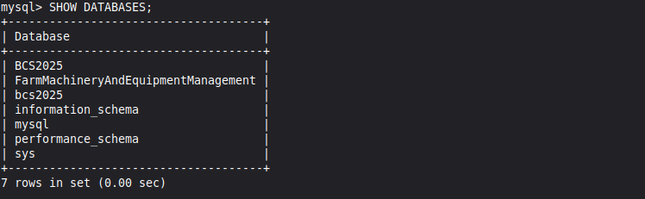
I inserted the tables into the database and their Attributes.
Using the command,
INSERT TABLE tableName(Attribute1,attribute2,....);
I inserted the records into the attributes using commands like; 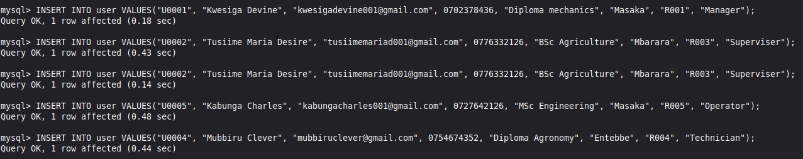
After successful INSERTION of the tables in my database,
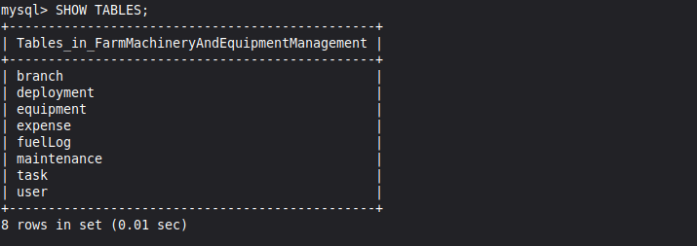

After inserting values in the attributes of the database,
I queried to see the table content using the SELECT command.
Task entity

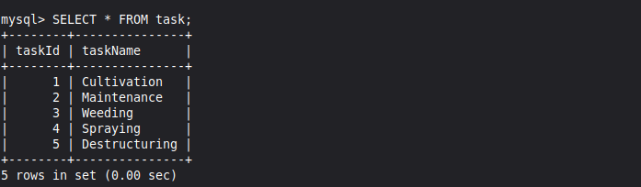
User entity
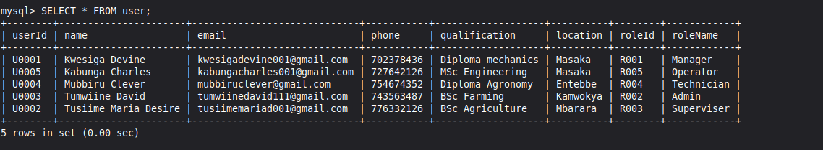
Maintenance entity
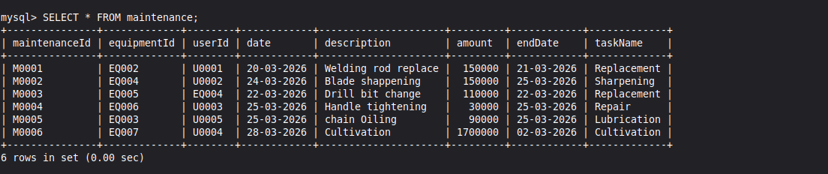
FuelLog entity
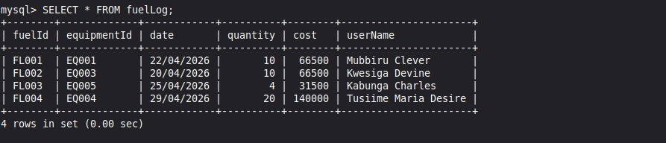
Expense entity
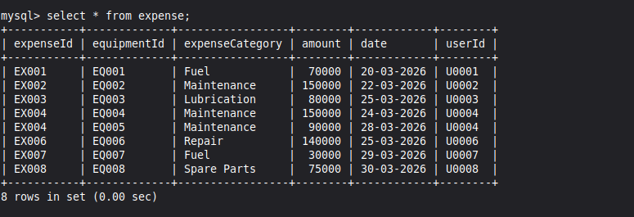
Equipment entity
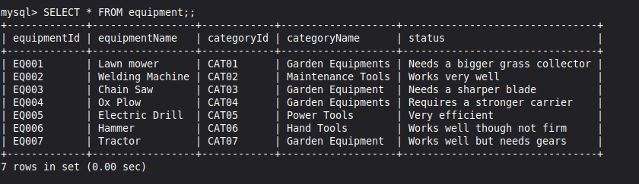
Deployment entity
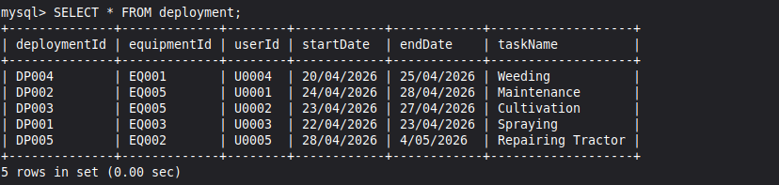
Branch entity
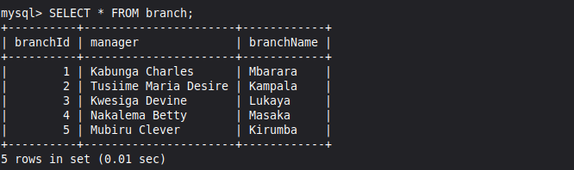

QUERY COMMANDING USING DML ON THE LOGICAL SCHEMA

I realised i had forgotten to add a column in expense table and i used the ALTER TABLE ‘ADD COLUMN‘ command to add userId as both tables have a relationship and userId will referebnce user table in the expense table helping in easy report making
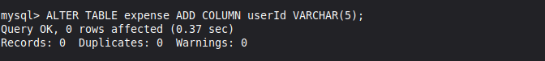
I used the UPDATE command to update record values misentered. Thus easy management due to data independency
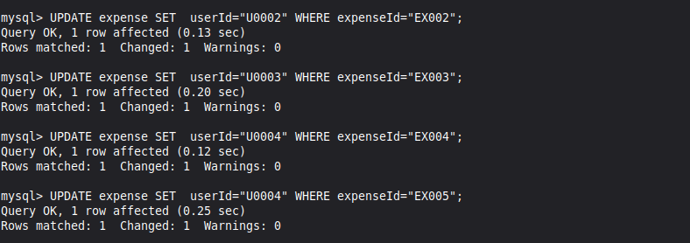
In some tables, i had not set the primary key and set them using ALTER TABLE ... ‘ADD PRIMARY KEY‘ .. command
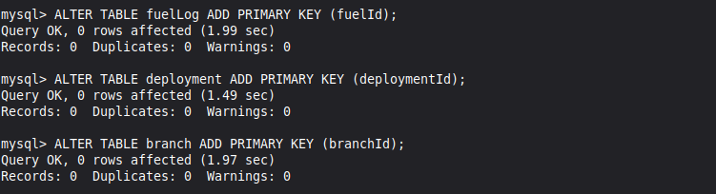
Selecting only users located in Mbarara easing task allocation
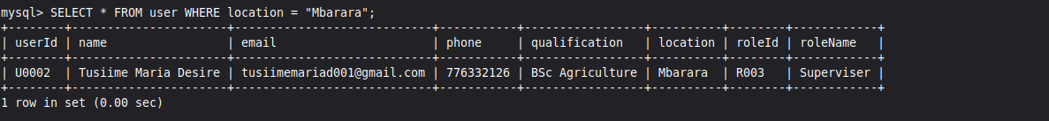
Selecting records in expense table whose amount is greater than 100000
This eases easy filtering of fields with a higher expense for better planning
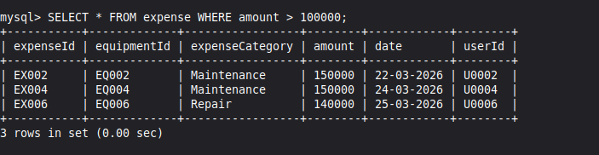

Using relational calculus JOIN command, i retrieved records in some attributes from maintenance and user tables with the same userId.
This enables quick reporrt making by knowing the operators and the respective tasks handled.
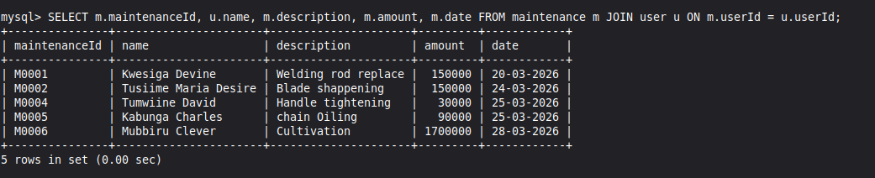
I ordered the records in maintenance table by date in ascending order, this helps a superviser to quickly know the sheduled tasks in their order and accomplished tasks for easy maintainability
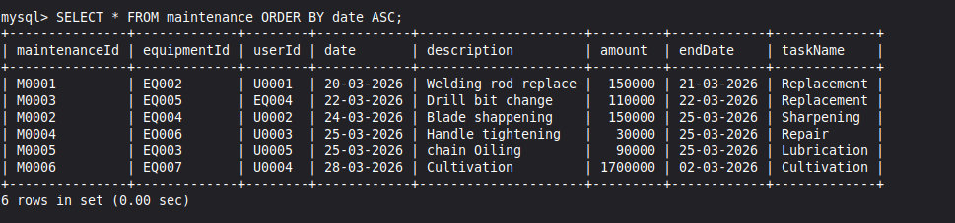

Conclusion
Farm Machinery and Equipment Management Database System provides a structured and the best efficient approach to managing agricultural machinery. By improving equipment tracking, maintenance scheduling, and operational planning, the system enhances productivity and reduces operational costs. Despite challenges such as user adoption and maintenance costs, the long-term benefits significantly justify its implementation, making it a viable and impactful solution in the agricultural sector.

Database Administrator and Designer: Kabunga Charles

